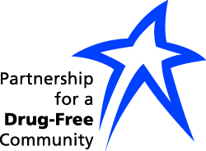

Donation to Partnership for a Drug-Free Community

EVERY DOLLAR MAKES A HUGE DIFFERENCE

Your gift, no matter how large or small, makes all the difference to educating our youth about current alcohol, tobacco and drug issues; or a person who is ready to try and build a better future. Every dollar is used to support our programs and services.

Date: __________________
Name: ___________________________________________________________
Home Phone: ________________________________ Cell: _______________
Email Address: ___________________________________________________
Address: _________________________________________________________
City: ______________________________ State: _________ ZIP: __________
Checks may be mailed to:

Partnership for a Drug-Free Community
Attention: Wendy Reeves — Acting Executive Director
P.O. Box 2603
Huntsville, AL 35804

Your contribution is tax deductible based on our 501 (c)(3) status.

THANK YOU!

