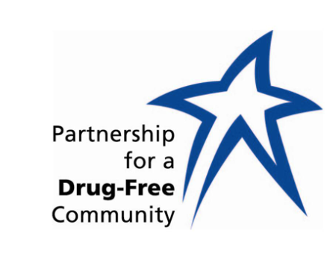

FOR IMMEDIATE RELEASE FOR MORE INFORMATION:
May 1, 2018 256-539-7339
info@partnershipforadrugfreecommunity.org
wendy.reeves@wynsum.net / 256-655-4593

Partnership for a Drug-Free Community Updates
BUILDING ON 30 YEARS OF COMMUNITY SUCCESS
New Program, Free drug-testing kits
New Executive Director, Candice Dunaway
New Office Location, 2201 Clinton Ave.

Huntsville, Ala. — In its 30th year, the Partnership for a Drug-Free Community has a new executive director and new office location as it evolves and continues its alcohol and drug prevention campaigns.

The nonprofit is also adding a new service to its arsenal by giving away free drug-testing kits.

“We are offering free drug testing kits to parents concerned about their teens’ potential drug use,” says Candice Dunaway, Partnership’s executive director. “This program is anonymous and parents will administer the tests in their home.”

Dunaway says the kits test for alcohol and various other drugs and are available at the Partnership office. Give the staff a call at 256-539-7339 and schedule a pick up time for a free kit.

The Partnership has seen a lot of transitions over the past six months, following the death of its longtime director, Deborah Soule.

The Partnership recently moved from its Five Points location to 2201 Clinton Avenue, at the One-Stop-Shop of Community Services.

Candice Dunaway was named executive director of the Partnership following Soule’s death last October. Dunaway has been deputy director of the organization since 2004.

“Losing Deborah was unexpected for Partnership and the community,” Dunaway says. “During a time when we have epidemic issues with opioids, heroine and fentanyl, just to name the ones that make headlines almost daily, as always we are committed to our mission and are doing our best to keep and maintain Partnership a viable resource in our community.”

In addition to Dunaway taking over the helm, Ann Light has joined the staff as office manager following the March retirement of Elaine Carlton, who will continue to volunteer with the group.

—30—

